Gaining access to FuturesNHS and Profile Settings – South-West Dental Network

You can self-register for the South-West Dental Network workspace here with your NHS email address, you will then have access to all the resources on the page.
Please see below for step-by-step instructions on how you can register.

If you already have a FutureNHS account, please log in using the link provided below:
FutureNHS Collaboration Platform - FutureNHS Collaboration Platform

- Please enter your email address and password
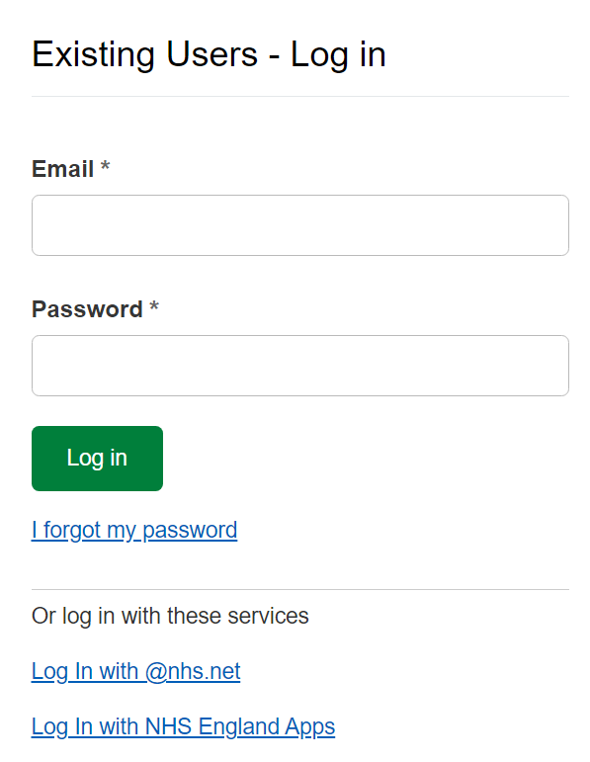

- On the search bar at the top of the screen, please enter South-West Dental Network

If you DO NOT have a NHSFutures account, please log in using the link below:
FutureNHS Collaboration Platform - FutureNHS Collaboration Platform
- Please enter details to register for an account.
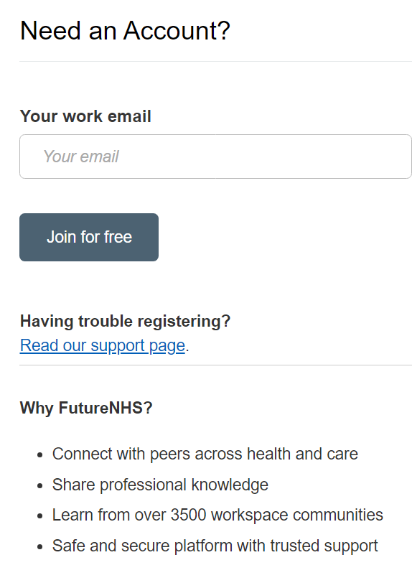
- Once you have provided a suitable email address you will receive the following message and asked to provide a memorable password
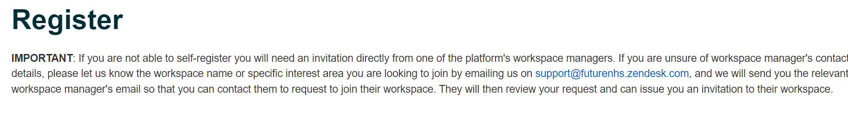
- You will be asked several questions which you will need to answer and ‘click’ join
- Once approved by admin, you will be a member of NHSFutures

Searching for a workspace
- On the search bar at the top of the screen, please enter South-West Dental Network
- Once you have located South-West Dental Network, complete the following questions
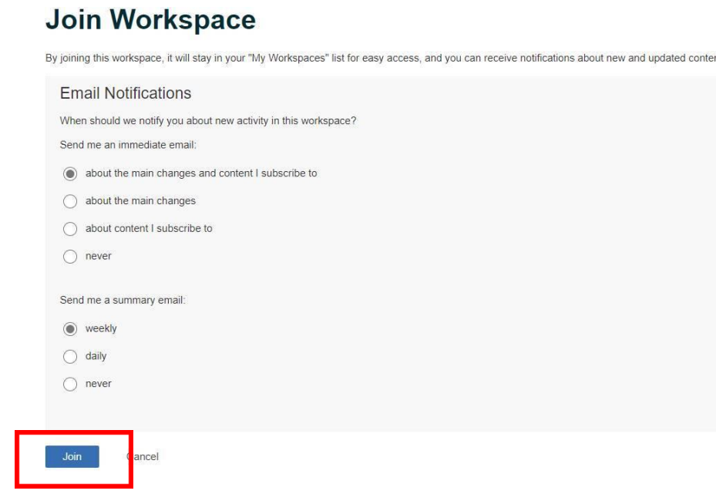
- If you are following the steps above and encounter any problems or issues, please contact us and we will try to support in any way we can
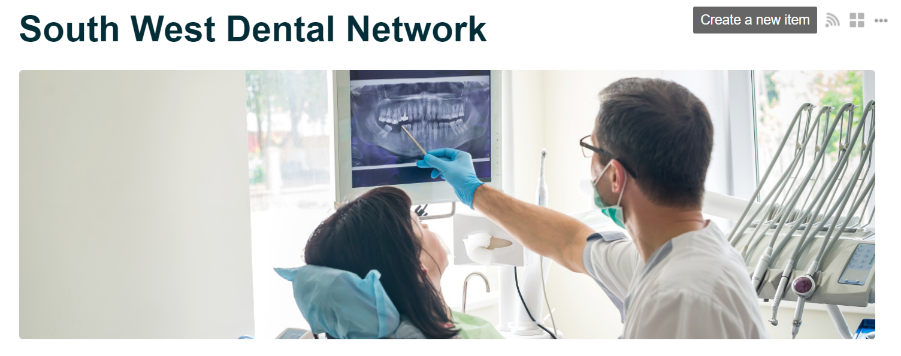

- Once your membership has been approved you will have access to lots of informative dental resources
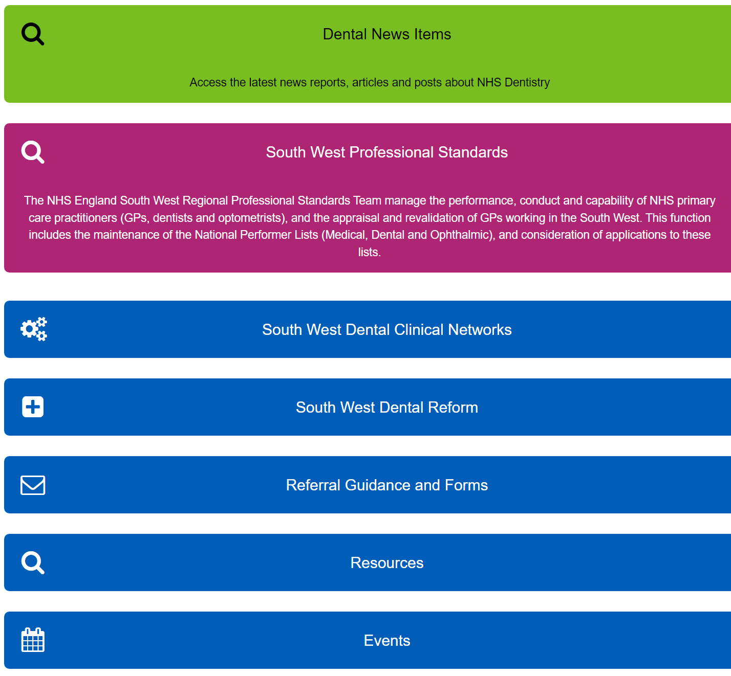

Changing your Email Preferences
- To change your email preferences visit drop down menu on left hand side of screen and select Account Settings

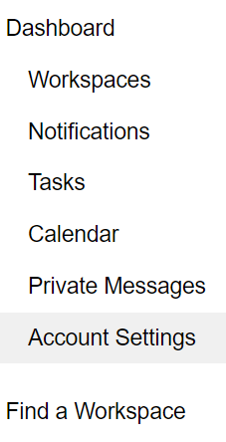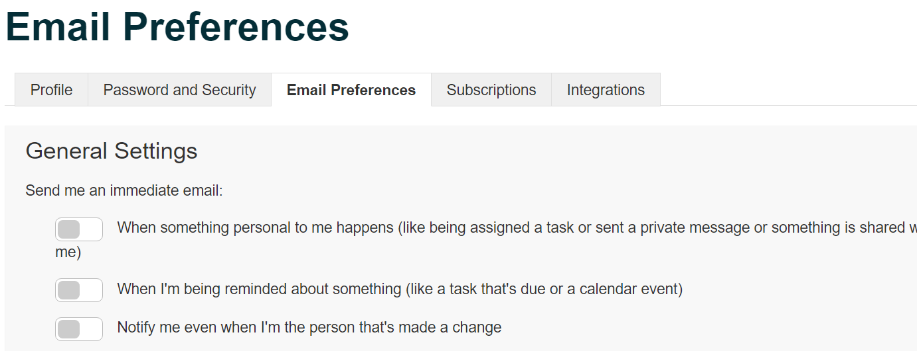

- When you select Email Preferences you can select to turn off notifications. This will mean you will NOT receive emails regarding messages, reminders, and / or changes.

